1. Create a PROJECT to do the following ONCE upon activation of the project:  
   - Open a dialog with the user to accept a STRING value, prompting the user to enter their**name and the current date**

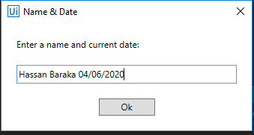

- write this dialogue result to the **Output** panel in the tool

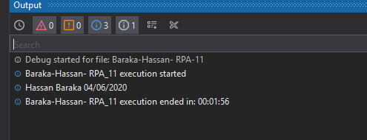  
- open a NEW Notepad file  
- write the same text in theNotepad file and save it titled : **<*Last Name - First Name*> - RPA_11.txt**(substitute your last name and first name value)**[5 points]**

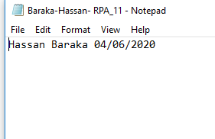

- set up a **HOTKEY** Trigger of **CNTL+ALT+M**  to execute the following steps when the user activates the Assistant Bot **[5 points]**

1. ATTACH a new BROWSER instance to the Project  
   - Navigate to [Amazon.com](https://www.amazon.com/s?k=rpa+books&ref=nb_sb_noss_1)

- FOR **EACH OF THE FOLLOWING iterations (remember, the content defined above in point 1 is performed ONCE, not each time through the Assistant Bot trigger) - Assistant Bot must repeat for FOUR iterations**:  
--> Enter the Search Term   
--> ACTIVATE THE ASSISTANT BOT **[5 points]**

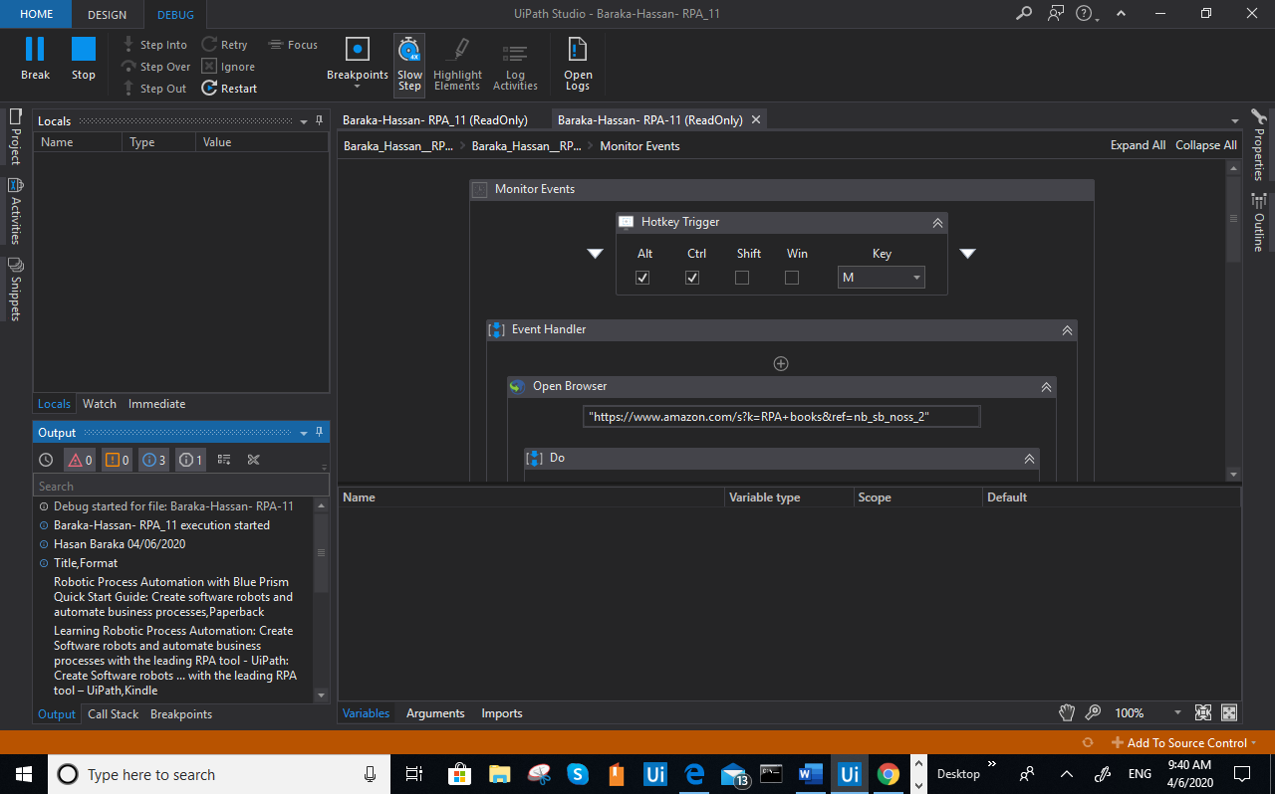*Search Terms*:  
RPA Book

Artificial Intelligence

Process Automation

Natural Language Processing

1. The Assistant Bot   
   - Extract ALL Book Titles and the related FORMAT (e.g. Paperback, Kindle, etc.) (on all PAGES for this search) to a MAXIMUM of 9 (nine) matching entries**[5 points]**

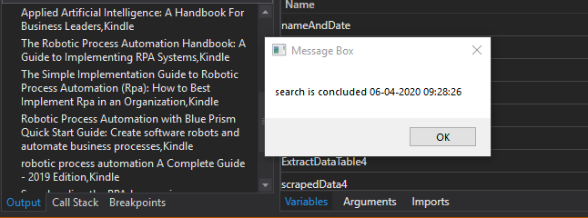

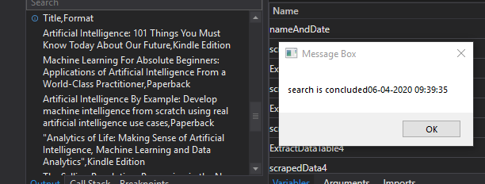

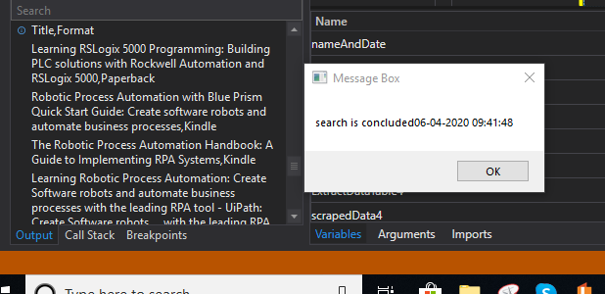

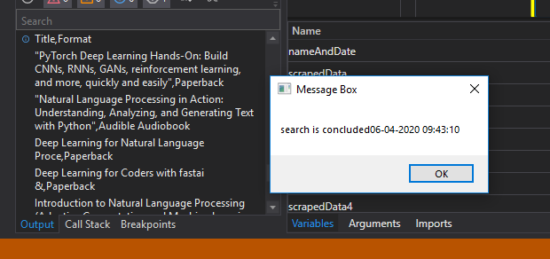

- Write message to the Notepad file  for each book TITLE which contains the term "**PROCESS**" containing the Title and Format **[5 points]**

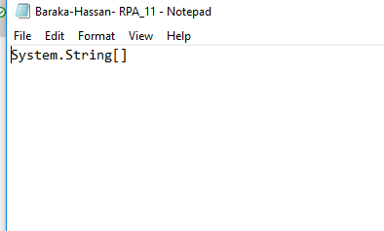

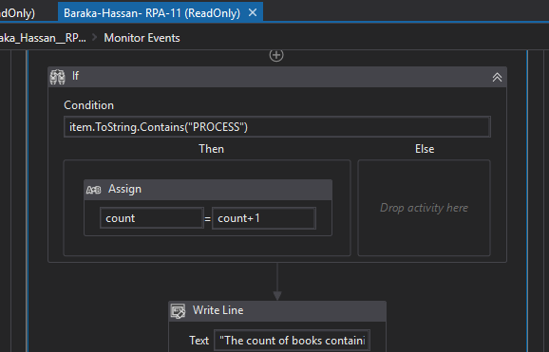  
- Output the Search Term and the COUNT of the titles containing "**PROCESS**" to the Output panel**[5 points]**

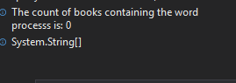

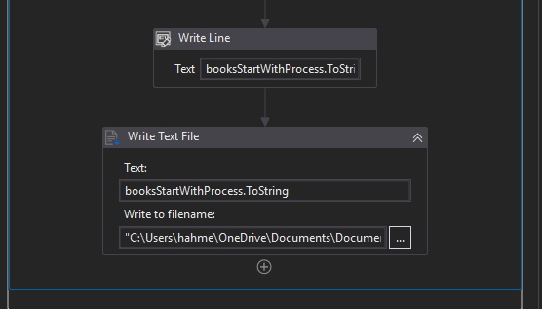

1. DEBUGGING messages  
   - Display the message "Search is concluded" and the current date/time  
   - At the conclusion of the email - Display a message to the User **"Af hebben  " + current date/time** and write this same message to the Output panel**[5 points]**



1. Submit a DOCUMENT containing screen captures of the Studio showing your project flow (multiple FLOWCHART Activities - one for each subsection)**[5 points]**  
   